**Behavioral Economics and Consumer Choice: Understanding Decision-Making Processes**

Table of Contents

Abstract 3

1. Introduction 4

1.1. Background 5

2. Literature Review 7

2.1. Research Gap 11

2.2. Research Objectives 11

2.3. Research Questions 11

2.4. Hypothesis 11

3. Research Methodology 12

3.1. Research Approach 12

3.2. Data Collection 12

3.3. Sampling Technique 12

3.4. Research Tools 12

3.5. Data Analysis 13

4. Data Analysis 14

4.1. Demographics 14

4.2. Behavioral Economics 18

4.3. Decision-making process 24

4.4. Customer choice 28

4.5. Impact of Behavioral Economics on Customer Choice 32

4.6. Impact of Behavioral Economics on Customers’ Decision-Making Process 33

5. Results 35

6. Conclusion 37

References 38

# Abstract

Consumers make a lot of decisions in daily lives like food, health, and finance. Consumers are usually obsessed with instant gratification and they are likely to go with quick, yet smaller, reward. In the same way, delaying the satisfaction, or going for delayed reward, can be helpful. This study is aimed to understand how to encourage consumers to resist instant gratification and prefer long-term gratification for healthy and sustainable benefits. This study gets an insight to recent advancements from neuroimaging and behavioral studies which are relevant to know customer decisions. This study is descriptive in nature and adopts both qualitative and quantitative approaches. It presents findings from online survey to understand whether behavioral economics affects consumers’ decision-making processes with tailored communication.

At the end, this study highlights the importance of behavioral economics when it comes to explain the process of decision-making. For proper knowledge of mechanisms and attitudes of decision-making, there is a need to consider psychological and subjective “behavioral economics” aspects and understand rational behavior from traditional aspects in neoclassical and classical studies. This decision-making approach affects the process of economic development. Researchers can have better understanding of economic issues and find ideal solutions by considering all factors of consumers’ decision-making.

*Keywords – decision-making, behavioral economics, consumer choice, rational behavior, instant gratification*

# Introduction

The landscape of marketing has been evolving rapidly and it makes it vital to understand consumer behavior. Consumers have always been assumed to make rational decisions as per complete information in conventional economic theories. Consumer behavior is far more complex in real life. Behavioral economics is an area which combines understandings from both economics and psychology. It has become a robust tool to decipher the complexities of decision-making and consumer choices (Shafiq et al., 2020).

The traditional economic model is challenged by behavioral economics by understanding that cognitive biases, social factors, and human emotions are the factors affecting human decisions. The field of behavioral economics is excelled by noble laureates “Amos Tversky and Daniel Kahneman” showing that people constantly deviate in the form of rationality in specific ways. They have laid the basis to understand emotional foundations of financial decisions. There might be several cognitive biases in consumers which affect their decision-making process. For example, when consumers depend highly on first piece of data available for decision-making, anchoring bias takes place.

This bias may be used by marketers smoothly by presenting valuable item in the beginning, making consecutive options available more cost-effective. Another cognitive mistake is confirmation bias where people are likely to seek details which confirm current beliefs. This bias can be used in marketing by reinforcing positive perceptions towards a brand with customer testimonials and targeted ads (Kock et al., 2020). Emotions play a vital role in understanding consumer behavior. It is found that emotional responses usually lead rational discussion when it comes to make buying decisions. There are some marketing campaigns which suggest positive emotions like nostalgia or happiness and build strong connection among brands and consumers. In the same way, loyalty and trust can be improved by addressing negative motions like anxiety or fear with consumer support or features of the product (Suppes et al., 2021).

Humans are naturally social and their choices are usually affected by peer options and social norms. Robert Cialdini popularized the idea of social proof, focusing on the likeliness of people to go with others’ actions in unexpected situations. Social media promotions, influencer marketing, and online reviews are potent tools to make the most of social influence, shaping customer preferences and perceptions. The concept of nudging is one of the sensible ways to apply behavioral economics. A nudge is a subtle change to present choices affecting decisions of the people without having to restrict their choices. For example, showing healthy food choices especially in cafeteria can promote healthy behavior. Customers may be guided by ethical nudges for making better decisions, encouraging social welfare without having to affect their freedom of choice (Davis et al., 2016).

In the competitive and dynamic marketing world, businesses need to embrace behavioral economics and its principles to have deeper connection with consumers. By understanding complex human decisions, marketers can design and plan campaigns which are both respectful and persuasive of inherent biases of consumers and their emotions, which ultimately help in socially responsible and best results (Li et al., 2022).

## Background

A lot of decisions in daily life involve choices which come up at some point. For example, when there is a choice between $5 for quick reward and $10 in few weeks, most people will go for the first option, despite getting smaller reward. Recent understandings have been increased on behavioral economics, especially on how people make those decisions in different contexts. Behavioral economics is a research area which involves psychological science to know how economic decisions are made overall by the people (Camerer, 1999). This field has been enhanced to neuroeconomics which focuses on role of brain functioning when it comes to evaluate decisions, categorize rewards and risks, and interactions with one another (Loewenstein et al., 2008).

The “time-discounted utility theory” is very interesting for economics. This theory describes subjective devaluation of results as a time delay function until final delivery in a way that quick rewards can be valued highly and have greater control over delayed behavior (Frederick et al., 2002). This study will discuss recent developments on factors affecting decision-making processes of customers, with special emphasis on behavioral economics related to delayed and immediate rewards. It would be followed by some primary data to increase value of delayed rewards to be more encouraging to customers.

# Literature Review

Neuromarketing is an emerging area with multiple disciplines combining neuroscience, economics, and consumer behavior to provide new approaches which are more effective than standard approaches when it comes to respond to evolving marketing conditions. Additionally, human behavior rules in consumer behavior, tourist activities, and psychology of consumers. All of these inclinations are affected by variables like perception, motivation, beliefs, learning, and attitudes in the process of decision-making when it comes to choose the right location in tourism industry. Halkiopoulos et al (2022) review conventional neuroscientific approaches like eye tracking to define consumer behavior and aspects of decision-making process along with higher cognitive processes engaged in choosing travel destination. In addition, they found that neurocognitive and cognitive aspects to forecast consumer behavior can be helpful to create database that can have stimulus data. All in all, integrating knowledge database and modern neuromarketing techniques is important to receive findings and export in the process of decision-making, especially in consumer behavior and tourism, perception, gender bias, and cognition.

There have been a lot of research advancements observed in recent decades on the relation between consumer decision-making and sustainable product qualities. Irrespective of considerable research, there are still contradictory and fragmented findings in this context. Bangsa & Schlegelmilch (2020) gave state-of-the-art review of huge body of research to reveal knowledge gaps and presented future research directions. In addition, they conducted systematic review of relation between decision-making of consumers and sustainable attributes of product from 2008 to 2018. Generally, this review has observed that a lot of studies assumed rational and linear process of consumer decision-making, focused on sustainability of environment, and examined food items. It is found that social sustainability is a highly neglected field.

Sahoo & Goswami (2023) presented a complete review of “Multiple Criteria Decision-Making (MCDM)” approaches, including their applications, advancements, and future research directions. They introduced the importance of MCDM in complex scenarios of decision-making. They examined the recent advancements in MCDM like fuzzy-based methods, multi-objective approaches, hybrid approaches, and data-driven models. They have also analyzed limitations and strengths of each approach critically. In addition, this study investigated various MCDM applications in domains like engineering, business, healthcare, public policy, and environment to highlight implications with case studies. Then, they identified emerging challenges and trends in research related to MCDM to discuss the integration with latest technologies to boost adaptability and robustness. This complete review was the important resource for researchers and decision-makers by giving insights to applications, developments, and future research directions.

The way traditional ecommerce portals work is revolutionized by omnichannel businesses to bring important changes to consumer’s decision-making and expectations. Irrespective of irresistible relevance of this domain, there is a lack of research on omnichannel retailing. Hence, Mishra et al. (2021) conducted research on concise and complete state of the art review on this aspect of retailing. They draw upon the “cognitive-affective-conative” research model to know behavior of consumers in context of omnichannel retailing. They conducted review of 131 studies which were identified with complete search on “Web of Science” database from January 2011 to April 2020. They review this set of research on the aims, key findings, and methodology. Along with proper evaluation and review of studies, they have also extended literature on the relation between consumer’s decision-making and omnichannel retailing, with special emphasis on customer attitude, motivation, and behavior. Earlier studies have observed that consumer behavior is known to be underexplored and promising in omnichannel retailing with various avenues for research. Some of the lucrative directions among these are cross-cultural studies, theoretical research, and qualitative methods to gather first-hand data related to decision-making of consumers. This study provided a holistic view of research on omnichannel retailing and provided evidence based on literature on several dimensions of consumer behavior. With “cognitive-affective-conative” model, customer responses have increased their knowledge of decision-making of consumers in omnichannel journey of consumers.

Mason et al. (2020) studied the effects of COVID-19 and pandemic interventions announced by the US government on consumer behaviors. They conducted critical analysis of studies published on marketing and healthcare to analyze macro changes in decision-making behaviors of consumers. To have the baseline for the effect of pandemic on perceptions of consumers, survey data was collected from consumers and compared post- and pre-declaration behavior of customers. It is found that COVID-19 pandemic has affected product needs, buying behavior, shopping behaviors, and post-purchase satisfaction of consumers. Since the beginning of pandemic, consumers are looking for ways to avoid products that are publicly consumed and increased their online buying and shopping behaviors. It is found that it may not be easy for marketers to make customers loyal.

Sharma (2021) presented the gap in context of green marketing between actual buying behavior and customer attitude for green products. They analyzed total 232 studies with a systematic review to develop the “green decision-making model.” A thematic analysis identified three major themes – green marketing mix, green buying behavior, and green purchase. They identified the concern for eco-labeling, eco-environment, perceived usefulness, and past experiences as key influencers of green behavior. Perceived associated risks, price, lack of knowledge, trust, organizational image, and wiliness to pay are the barriers to have a gap between actual buying behavior and customers’ attitude for green products. They have proposed a green buying decision model as per the analysis and potential areas of research.

Lăzăroiu et al. (2020) improved existing knowledge on the role of “online perceived risk” and trust in shaping buying decision-making of consumers in social commerce. This study investigated the process of buying decision of consumers, components of social commerce attitudes and buying intentions, and impact of perceived risk on intention to shop online, and buying behavior and consumer trust on online platforms. The insights from the research go beyond existing knowledge regarding factors of customer intent and attitudes for online shopping, perceived shopping risk of customers, and repurchase behavior when it comes to shop products online, buying decisions and perceived online trust of customers. There is lack of research on decision-making of consumers on social commerce by focusing on how their behavioral intent, perceptual attitudes, and instant gratifications affected the online shopping of services and products. The researchers extended prior understanding and research on relation between adoption behavior of social commerce, buying intention of online consumers, and trust of consumers along with risk factors on online shopping decisions in light of source credibility. Findings of the study pointed significant avenues of studies on psychological factors of engagement of customers in decision-making, social media, perceived risk, intention on social commerce, and online repurchasing. Succeeding directions must define whether adopting mobile payments should shape impulsive decision-making and buying behavior of online customers, especially under the impact of online reviews.

Raut (2020) explored the value of financial literacy and previous behavior in making investment decisions of investors and validity of “theory of planned behavior”. Self-structured questionnaire was used and convenience sampling was adopted after snowball sampling for collecting data from small investors to cover four different states of the nation. The researcher has analyzed gathered data on “AMOS 20.0” with “2-step structural equation modeling (SEM)”. Significant impact of all variables have been found in the results. There had no significant and direct impact of past behavior on investors’ intention. But there was indirect significant relation between past behavior and investors’ intention when mediating the investors’ attitudes. With “multiple squared correlation (R2)”, it is observed that final model can define 36% of variance in intention of investors for stock investment which signified implementing TPB model apart from external variables. In addition, investors in India were known to be highly impacted, preferably, by social pressure which can be controlled with financial literacy. Stock market participation had major value of subjective norms that might be strategic theme for policymakers and government to teach investors to improve participation of opinion leaders. Investors can make rational decisions and manage their behavior with investors. This study has elevated knowledge of decision-makers.

Low-income groups are usually blamed for making decisions which can be harmful to them in the long term. Sheehy-Skeffington (2020) conducted a review of recent research on understanding the patterns of decision-making as “adaptive response to low socioeconomic status.” It is proposed that socio-ecological cues are presented by low income contexts on “environmental instability, resource scarcity, and low subjective social status” triggering a financial shift for cognitive skills to meet quick needs. In psychological processes, these changes lead to rational decisions in proximal level of socioeconomic risks but they may affect distal goals.

## Research Gap

As discussed in above studies, there is very little research on consumer decision making in context of behavioral economics. Hence, this study will fill this knowledge gap by discussing the factors impacting customer choice in terms of delayed versus quick reward. This research holds much importance for future studies which may focus on “behavioral economics and economic decisions of customers in different industries.

## Research Objectives

* To discuss the factors impacting customers’ decision-making process
* To find out the impact of behavioral economics on customer choice

## Research Questions

* What are the factors impacting customers’ decision-making process?
* What is the impact of behavioral economics on customer choice?

## Hypothesis

H1 – There is a significant impact of behavioral economics on customer choice

H01 – There is no significant impact of behavioral economics on customer choice

H2 – There is a significant impact of behavioral economics on customers’ decision-making process

H02 – There is no significant impact of behavioral economics on customers’ decision-making process

H3 – There is a significant correlation between customer choice and decision-making process

H03 – There is no significant correlation between customer choice and decision-making process

# Research Methodology

## Research Approach

In order to fulfill above objectives, this study adopts both quantitative and qualitative research approach as it involves collecting both primary and secondary data. These approaches are considered to be important when it comes to collect evidence on behavioral contexts.

## Data Collection

Primary data has been collected through self-structured questionnaire prepared and distributed using Google Form, which involves demographic details of participants along with their opinion on behavioral economics, decision-making, and customer choice. In addition, secondary data has been collected through review of previous studies based on consumer behavior and decision-making processes to make theoretical understanding of underlying topic.

## Sampling Technique

Simple random sampling has been employed for collecting primary data for this study as it is collected from random participants who can understand basic English language and give answer about their buying behavior and decision-making processes when they are encountered with instant gratification and rewards. With this sampling technique, total 156 responses have been collected for primary data.

## Research Tools

This study has been conducted using Excel spreadsheet and IBM SPSS software to analyze primary data. In addition, this study needs basic research tools like –

* MS Office
* IBM SPSS software 22.0 or later version
* Excel Spreadsheet
* Personal Computer
* Internet connection

## Data Analysis

For hypothesis testing, one-sample t-test and Pearson’s correlation will be performed using SPSS 22.0 software. In addition, primary data will be analyzed using Excel spreadsheet for defining frequency of responses.

# Data Analysis

## Demographics

There are 58 (37%) participants who are above 45 years old, 39 (25%) participants are 36 to 45 years old, 35 (22%) participants are 26 to 35 years old and 24 (15%) participants are 18 to 25 years old (Table 1) (Figure 1).

|  |  |  |  |  |  |
| --- | --- | --- | --- | --- | --- |
| **Table 1 - Age** | | | | | |
|  | | Frequency | Percent | Valid Percent | Cumulative Percent |
| Valid | 18 to 25 years | 24 | 15.4 | 15.4 | 15.4 |
| 26 to 35 years | 35 | 22.4 | 22.4 | 37.8 |
| 36 to 45 years | 39 | 25.0 | 25.0 | 62.8 |
| Above 45 years | 58 | 37.2 | 37.2 | 100.0 |
| Total | 156 | 100.0 | 100.0 |  |

Figure 1 – Age

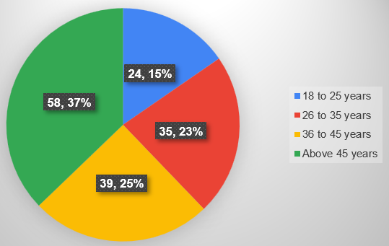

In this study, 65 (42%) participants are female and 91 (58%) participants are male (Table 2) (Figure 2).

|  |  |  |  |  |  |
| --- | --- | --- | --- | --- | --- |
| **Table 2 - Gender** | | | | | |
|  | | Frequency | Percent | Valid Percent | Cumulative Percent |
| Valid | Female | 65 | 41.7 | 41.7 | 41.7 |
| Male | 91 | 58.3 | 58.3 | 100.0 |
| Total | 156 | 100.0 | 100.0 |  |

Figure 2 – Gender

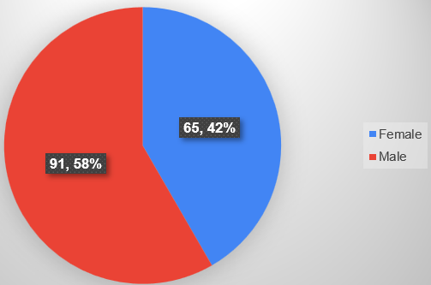

When it comes to occupation, 43 (28%) participants are entrepreneurs, 47 (30%) participants are self-employed, 28 (18%) participants are students, 13 (8%) participants are private employees, 3 (2%) participants are government employees, and 22 (14%) participants had other occupation (Table 3) (Figure 3).

|  |  |  |  |  |  |
| --- | --- | --- | --- | --- | --- |
| **Table 3 - Occupation** | | | | | |
|  | | Frequency | Percent | Valid Percent | Cumulative Percent |
| Valid | Entrepreneur | 43 | 27.6 | 27.6 | 27.6 |
| Govt Employee | 3 | 1.9 | 1.9 | 29.5 |
| Other | 22 | 14.1 | 14.1 | 43.6 |
| Private employee | 13 | 8.3 | 8.3 | 51.9 |
| Self-employed | 47 | 30.1 | 30.1 | 82.1 |
| Student | 28 | 17.9 | 17.9 | 100.0 |
| Total | 156 | 100.0 | 100.0 |  |

**Figure 3** – Occupation

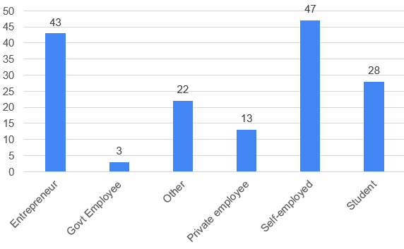

When it comes to educational qualification, 91 (58%) participants are graduate, 61 (39%) participants are post-graduate, and 4 (3%) participants have completed high school education (Table 4) (Figure 4).

|  |  |  |  |  |  |
| --- | --- | --- | --- | --- | --- |
| **Table 4 - Educational Qualification** | | | | | |
|  | | Frequency | Percent | Valid Percent | Cumulative Percent |
| Valid | Graduation | 91 | 58.3 | 58.3 | 58.3 |
| High School | 4 | 2.6 | 2.6 | 60.9 |
| Post Graduation | 61 | 39.1 | 39.1 | 100.0 |
| Total | 156 | 100.0 | 100.0 |  |

**Figure 4** – Educational Qualification

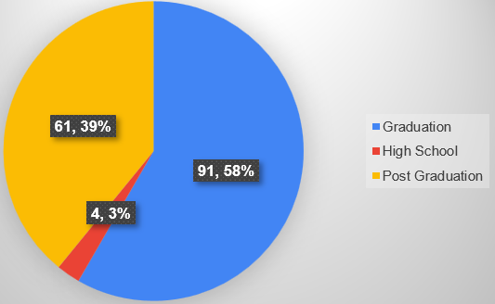

## Behavioral Economics

There are 87 (56%) participants who agree and 18 (12%) participants strongly agree that they adopt simple rules of thumb when making decisions instead of being completely rational, while 33 (21%) participants were neutral, 11 (7%) participants disagree and 7 (4%) participants strongly disagree (Table 5) (Figure 5).

|  |  |  |  |  |  |
| --- | --- | --- | --- | --- | --- |
| **Table 5 - Instead of being completely rational, you adopt simple rules of thumb when making decisions** | | | | | |
|  | | Frequency | Percent | Valid Percent | Cumulative Percent |
| Valid | Strongly Disagree | 7 | 4.5 | 4.5 | 4.5 |
| Disagree | 11 | 7.1 | 7.1 | 11.5 |
| Neutral | 33 | 21.2 | 21.2 | 32.7 |
| Agree | 87 | 55.8 | 55.8 | 88.5 |
| Strongly Agree | 18 | 11.5 | 11.5 | 100.0 |
| Total | 156 | 100.0 | 100.0 |  |

**Figure 5** - Instead of being completely rational, you adopt simple rules of thumb when making decisions

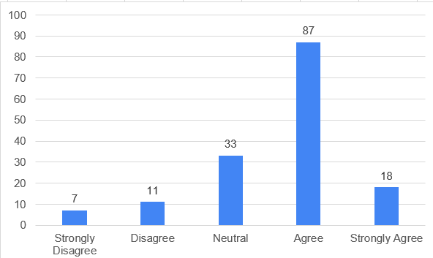

There are 88 (56%) participants who agree and 24 (15%) participants who strongly agree that they depend on information which is easily available when buying, while 34 (22%) participants were neutral, 3 (2%) participants disagree, and 7 (5%) participants strongly disagree (Table 6) (Figure 6).

|  |  |  |  |  |  |
| --- | --- | --- | --- | --- | --- |
| **Table 6 - When buying, you depend on information which is easily available** | | | | | |
|  | | Frequency | Percent | Valid Percent | Cumulative Percent |
| Valid | Strongly Disagree | 7 | 4.5 | 4.5 | 4.5 |
| Disagree | 3 | 1.9 | 1.9 | 6.4 |
| Neutral | 34 | 21.8 | 21.8 | 28.2 |
| Agree | 88 | 56.4 | 56.4 | 84.6 |
| Strongly Agree | 24 | 15.4 | 15.4 | 100.0 |
| Total | 156 | 100.0 | 100.0 |  |

Figure 6 – When buying, you depend on information which is easily available

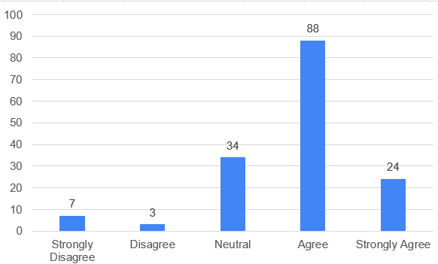

There are 57 (37%) participants who agree and 68 (44%) participants strongly agree that they choose avoiding losses over acquiring gains when making purchase decisions, while 8 (5%) participants were neutral, 8 (5%) participants disagree, and 15 (10%) participants strongly disagree (Table 7) (Figure 7).

|  |  |  |  |  |  |
| --- | --- | --- | --- | --- | --- |
| **Table 7 - You choose avoiding losses over acquiring gains when making purchase decisions** | | | | | |
|  | | Frequency | Percent | Valid Percent | Cumulative Percent |
| Valid | Strongly Disagree | 15 | 9.6 | 9.6 | 9.6 |
| Disagree | 8 | 5.1 | 5.1 | 14.7 |
| Neutral | 8 | 5.1 | 5.1 | 19.9 |
| Agree | 57 | 36.5 | 36.5 | 56.4 |
| Strongly Agree | 68 | 43.6 | 43.6 | 100.0 |
| Total | 156 | 100.0 | 100.0 |  |

Figure 7 - You choose avoiding losses over acquiring gains when making purchase decisions

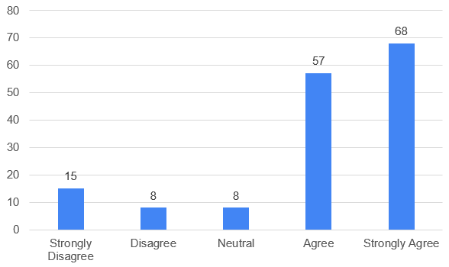

There are 72 (46%) participants who agree and 38 (24%) participants strongly agree that they evaluate possible losses or gains as per status quo, while 27 (17%) participants neither agree nor disagree, 12 (8%) participants disagree, and 7 (5%) participants strongly disagree (Table 8) (Figure 8).

|  |  |  |  |  |  |
| --- | --- | --- | --- | --- | --- |
| **Table 8 -** **You evaluate possible gains or losses based on status quo** | | | | | |
|  | | Frequency | Percent | Valid Percent | Cumulative Percent |
| Valid | Strongly Disagree | 7 | 4.5 | 4.5 | 4.5 |
| Disagree | 12 | 7.7 | 7.7 | 12.2 |
| Neutral | 27 | 17.3 | 17.3 | 29.5 |
| Agree | 72 | 46.2 | 46.2 | 75.6 |
| Strongly Agree | 38 | 24.4 | 24.4 | 100.0 |
| Total | 156 | 100.0 | 100.0 |  |

Figure 8 – You evaluate possible gains or losses based on status quo

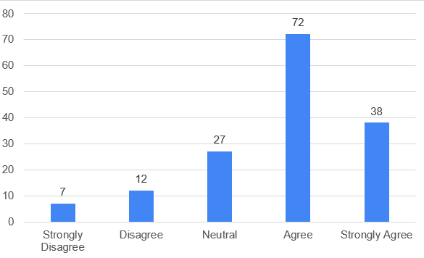

There are 50 (32%) participants who agree and 58 (37%) participants who strongly agree that they tend to avoid risk when choices are based on potential gains, while 22 (14%) participants were neutral, 11 (7%) participants disagree, and 15 (10%) participants strongly disagree (Table 9) (Figure 9).

|  |  |  |  |  |  |
| --- | --- | --- | --- | --- | --- |
| **Table 9 - You tend to avoid risk when choices are based on potential gains** | | | | | |
|  | | Frequency | Percent | Valid Percent | Cumulative Percent |
| Valid | Strongly Disagree | 15 | 9.6 | 9.6 | 9.6 |
| Disagree | 11 | 7.1 | 7.1 | 16.7 |
| Neutral | 22 | 14.1 | 14.1 | 30.8 |
| Agree | 50 | 32.1 | 32.1 | 62.8 |
| Strongly Agree | 58 | 37.2 | 37.2 | 100.0 |
| Total | 156 | 100.0 | 100.0 |  |

Figure 9 – You tend to avoid risk when choices are based on potential gains

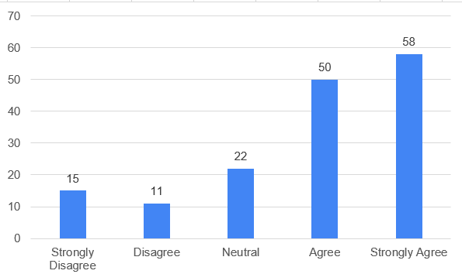

There are 100 (64%) participants who strongly agree and 46 (30%) participants who agree that they adopt healthy behavior when they observe long-term benefits from a product, while only 10 (6%) participants neither agree nor disagree (Table 10) (Figure 10).

|  |  |  |  |  |  |
| --- | --- | --- | --- | --- | --- |
| **Table 10 - You adopt healthy behavior when you see long-term benefits from a product** | | | | | |
|  | | Frequency | Percent | Valid Percent | Cumulative Percent |
| Valid | Neutral | 10 | 6.4 | 6.4 | 6.4 |
| Agree | 46 | 29.5 | 29.5 | 35.9 |
| Strongly Agree | 100 | 64.1 | 64.1 | 100.0 |
| Total | 156 | 100.0 | 100.0 |  |

Figure 10 - You adopt healthy behavior when you see long-term benefits from a product

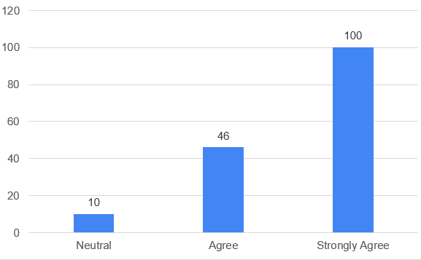

## Decision-making process

When it comes to decision making process, 50 (32%) participants agree and 62 (40%) participants strongly agree that they make decisions immediately as they recognize the need for a service or product, while 27 (17%) participants neither agree nor disagree, 14 (9%) participants disagree, and 3 (2%) participants strongly disagree (Table 11) (Figure 11).

|  |  |  |  |  |  |
| --- | --- | --- | --- | --- | --- |
| **Table 11 - You make decisions immediately as you recognize need for a product or service** | | | | | |
|  | | Frequency | Percent | Valid Percent | Cumulative Percent |
| Valid | Strongly Disagree | 3 | 1.9 | 1.9 | 1.9 |
| Disagree | 14 | 9.0 | 9.0 | 10.9 |
| Neutral | 27 | 17.3 | 17.3 | 28.2 |
| Agree | 50 | 32.1 | 32.1 | 60.3 |
| Strongly Agree | 62 | 39.7 | 39.7 | 100.0 |
| Total | 156 | 100.0 | 100.0 |  |

Figure 11 – You make decisions immediately as you recognize need for a product or service

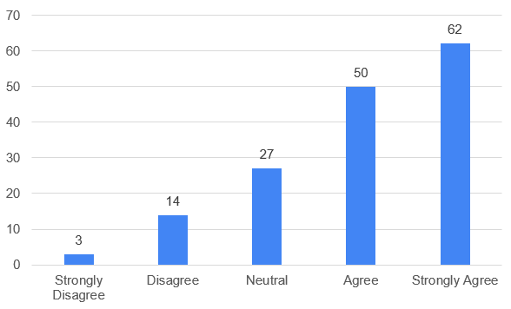

There are 112 (72%) participants who agree and 23 (15%) participants who strongly agree that they act as they get the information they want when making buying decision, while 11 (7%) participants neither agree nor disagree and 10 (6%) participants disagree (Table 12) (Figure 12).

|  |  |  |  |  |  |
| --- | --- | --- | --- | --- | --- |
| **Table 12 -** **When making purchase decision, you act as you get the information you want** | | | | | |
|  | | Frequency | Percent | Valid Percent | Cumulative Percent |
| Valid | Disagree | 10 | 6.4 | 6.4 | 6.4 |
| Neutral | 11 | 7.1 | 7.1 | 13.5 |
| Agree | 112 | 71.8 | 71.8 | 85.3 |
| Strongly Agree | 23 | 14.7 | 14.7 | 100.0 |
| Total | 156 | 100.0 | 100.0 |  |

Figure 12 – When making purchase decision, you act as you get the information you want

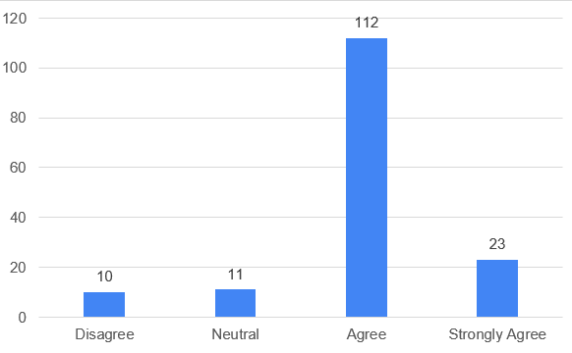

There are 53 (34%) participants who agree and 28 (18%) participants strongly agree that they make decisions based on customer reviews or video testimonials, while 55 (35%) participants neither agree nor disagree, 16 (10%) participants disagree and 4 (3%) participants strongly disagree (Table 13) (Figure 13).

|  |  |  |  |  |  |
| --- | --- | --- | --- | --- | --- |
| **Table 13 - You make decisions based on customer reviews or video testimonials** | | | | | |
|  | | Frequency | Percent | Valid Percent | Cumulative Percent |
| Valid | Strongly Disagree | 4 | 2.6 | 2.6 | 2.6 |
| Disagree | 16 | 10.3 | 10.3 | 12.8 |
| Neutral | 55 | 35.3 | 35.3 | 48.1 |
| Agree | 53 | 34.0 | 34.0 | 82.1 |
| Strongly Agree | 28 | 17.9 | 17.9 | 100.0 |
| Total | 156 | 100.0 | 100.0 |  |

Figure 13 – You make decisions based on customer reviews or video testimonials

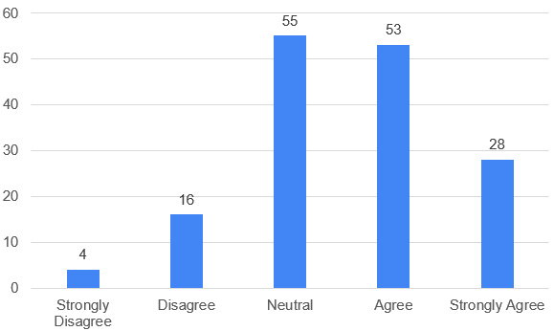

There are 53 (34%) participants who agree and 72 (46%) participants who strongly agree that they compare options they like before making buying decisions, while 16 (10%) participants were neutral, and 15 (10%) participants disagree (Table 14) (Figure 14).

|  |  |  |  |  |  |
| --- | --- | --- | --- | --- | --- |
| **Table 14 - You compare options you like before making purchase decisions** | | | | | |
|  | | Frequency | Percent | Valid Percent | Cumulative Percent |
| Valid | Disagree | 15 | 9.6 | 9.6 | 9.6 |
| Neutral | 16 | 10.3 | 10.3 | 19.9 |
| Agree | 53 | 34.0 | 34.0 | 53.8 |
| Strongly Agree | 72 | 46.2 | 46.2 | 100.0 |
| Total | 156 | 100.0 | 100.0 |  |

Figure 14 - You compare options you like before making purchase decisions

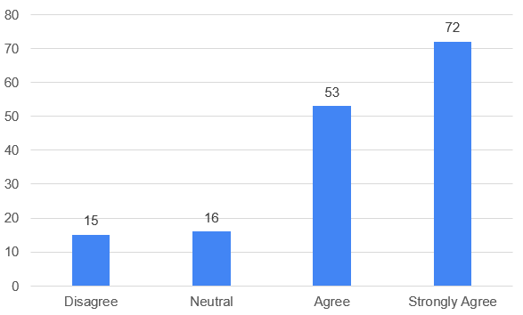

## Customer choice

There are 53 (34%) participants who agree and 42 (27%) participants who strongly agree that they prefer instant gratification over long-term rewards when shopping online or offline, while 29 (19%) participants neither agree nor disagree, 24 (15%) participants disagree and 8 (5%) participants strongly disagree (Table 15) (Figure 15).

|  |  |  |  |  |  |
| --- | --- | --- | --- | --- | --- |
| **Table 15 -** **You choose instant gratification over long-term rewards when shopping online or offline** | | | | | |
|  | | Frequency | Percent | Valid Percent | Cumulative Percent |
| Valid | Strongly Disagree | 8 | 5.1 | 5.1 | 5.1 |
| Disagree | 24 | 15.4 | 15.4 | 20.5 |
| Neutral | 29 | 18.6 | 18.6 | 39.1 |
| Agree | 53 | 34.0 | 34.0 | 73.1 |
| Strongly Agree | 42 | 26.9 | 26.9 | 100.0 |
| Total | 156 | 100.0 | 100.0 |  |

Figure 15 - You choose instant gratification over long-term rewards when shopping online or offline

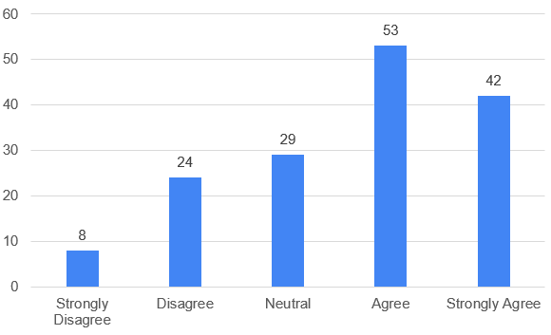

There are 56 (36%) participants who agree and 63 (40%) participants strongly agree that they choose services or products once they collect all the information they need, while 22 (14%) participants neither agree nor disagree, 11 (7%) participants disagree, and 4 (3%) participants strongly disagree (Table 16) (Figure 16).

|  |  |  |  |  |  |
| --- | --- | --- | --- | --- | --- |
| **Table 16 - You choose products or services once you gather all the information you need** | | | | | |
|  | | Frequency | Percent | Valid Percent | Cumulative Percent |
| Valid | Strongly Disagree | 4 | 2.6 | 2.6 | 2.6 |
| Disagree | 11 | 7.1 | 7.1 | 9.6 |
| Neutral | 22 | 14.1 | 14.1 | 23.7 |
| Agree | 56 | 35.9 | 35.9 | 59.6 |
| Strongly Agree | 63 | 40.4 | 40.4 | 100.0 |
| Total | 156 | 100.0 | 100.0 |  |

Figure 16 – You choose products or services once you gather all the information you need

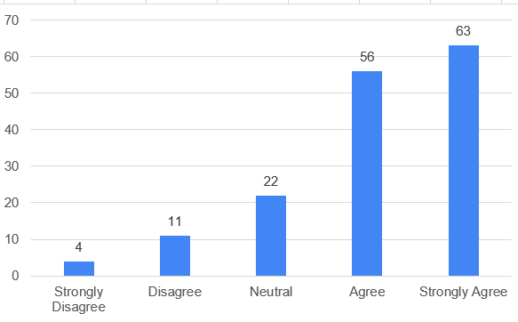

There are 83 (53%) participants agree and 47 (30%) participants strongly agree that they identify most pressing needs when choosing a specific product, while 19 (12%) participants were neutral, and 7 (4%) participants disagree (Table 17) (Figure 17).

|  |  |  |  |  |  |
| --- | --- | --- | --- | --- | --- |
| **Table 17 - You identify most pressing needs when choosing a particular product** | | | | | |
|  | | Frequency | Percent | Valid Percent | Cumulative Percent |
| Valid | Disagree | 7 | 4.5 | 4.5 | 4.5 |
| Neutral | 19 | 12.2 | 12.2 | 16.7 |
| Agree | 83 | 53.2 | 53.2 | 69.9 |
| Strongly Agree | 47 | 30.1 | 30.1 | 100.0 |
| Total | 156 | 100.0 | 100.0 |  |

Figure 17 – You identify most pressing needs when choosing a particular product

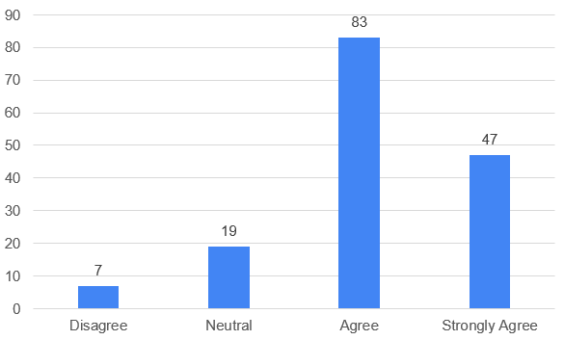

There are 63 (40%) participants who agree and 42 (27%) participants strongly agree that they choose products that can last longer, no matter how expensive they are, while 32 (21%) participants neither agree nor disagree, 11 (7%) participants disagree, and 8 (5%) participants strongly disagree (Table 18) (Figure 18).

|  |  |  |  |  |  |
| --- | --- | --- | --- | --- | --- |
| **Table 18 - You choose products that can last longer, no matter how expensive they are** | | | | | |
|  | | Frequency | Percent | Valid Percent | Cumulative Percent |
| Valid | Strongly Disagree | 8 | 5.1 | 5.1 | 5.1 |
| Disagree | 11 | 7.1 | 7.1 | 12.2 |
| Neutral | 32 | 20.5 | 20.5 | 32.7 |
| Agree | 63 | 40.4 | 40.4 | 73.1 |
| Strongly Agree | 42 | 26.9 | 26.9 | 100.0 |
| Total | 156 | 100.0 | 100.0 |  |

Figure 18 – You choose products that can last longer, no matter how expensive they are

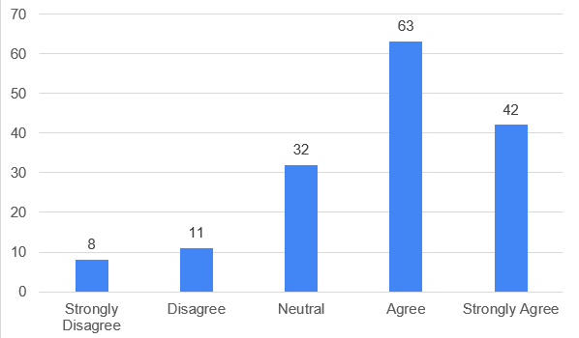

## Impact of Behavioral Economics on Customer Choice

When it comes to find out the impact of behavioral economics on customer choice, one sample t-test has been performed using SPSS software. It is observed that significant value is less than 0.005 of items of both variables, i.e., behavioral economics and consumer choice. It is inferred that H1 is approved, i.e., there is a significant impact of behavioral economics on customer choice (Table 19).

|  |  |  |  |  |  |  |
| --- | --- | --- | --- | --- | --- | --- |
| **Table 19 - One-Sample Test** | | | | | | |
|  | Test Value = 0 | | | | | |
| t | df | Sig.  (2-tailed) | Mean Difference | 95% Confidence Interval of the Difference | |
| Lower | Upper |
| Instead of being completely rational, you adopt simple rules of thumb when making decisions | 48.301 | 155 | .000 | 3.628 | 3.48 | 3.78 |
| When buying, you depend on information which is easily available | 52.497 | 155 | .000 | 3.763 | 3.62 | 3.90 |
| You choose avoiding losses over acquiring gains when making purchase decisions | 39.838 | 155 | .000 | 3.994 | 3.80 | 4.19 |
| You evaluate possible gains or losses based on status quo | 45.294 | 155 | .000 | 3.782 | 3.62 | 3.95 |
| You tend to avoid risk when choices are based on potential gains | 37.174 | 155 | .000 | 3.801 | 3.60 | 4.00 |
| You adopt healthy behavior when you see long-term benefits from a product | 93.390 | 155 | .000 | 4.577 | 4.48 | 4.67 |
| You choose instant gratification over long-term rewards when shopping online or offline | 38.259 | 155 | .000 | 3.622 | 3.43 | 3.81 |
| You choose products or services once you gather all the information you need | 49.012 | 155 | .000 | 4.045 | 3.88 | 4.21 |
| You identify most pressing needs when choosing a particular product | 66.036 | 155 | .000 | 4.090 | 3.97 | 4.21 |
| You choose products that can last longer, no matter how expensive they are | 43.482 | 155 | .000 | 3.769 | 3.60 | 3.94 |

## Impact of Behavioral Economics on Customers’ Decision-Making Process

In order to find out the impact of behavioral economics on consumers’ decision-making, one sample t-test has been performed. It is found that value of sig. (2-tailed) is again 0.000 (p<0.005) for all the items of both variables, i.e., decision-making process and behavioral economics. It is inferred that H2 is approved, i.e., there is a significant impact of behavioral economics on consumers’ decision-making process (Table 20).

|  |  |  |  |  |  |  |
| --- | --- | --- | --- | --- | --- | --- |
| **Table 20 - One-Sample Test** | | | | | | |
|  | Test Value = 0 | | | | | |
| t | df | Sig.  (2-tailed) | Mean Difference | 95% Confidence Interval of the Difference | |
| Lower | Upper |
| Instead of being completely rational, you adopt simple rules of thumb when making decisions | 48.301 | 155 | .000 | 3.628 | 3.48 | 3.78 |
| When buying, you depend on information which is easily available | 52.497 | 155 | .000 | 3.763 | 3.62 | 3.90 |
| You choose avoiding losses over acquiring gains when making purchase decisions | 39.838 | 155 | .000 | 3.994 | 3.80 | 4.19 |
| You evaluate possible gains or losses based on status quo | 45.294 | 155 | .000 | 3.782 | 3.62 | 3.95 |
| You tend to avoid risk when choices are based on potential gains | 37.174 | 155 | .000 | 3.801 | 3.60 | 4.00 |
| You adopt healthy behavior when you see long-term benefits from a product | 93.390 | 155 | .000 | 4.577 | 4.48 | 4.67 |
| You make decisions immediately as you recognize need for a product or service | 47.278 | 155 | .000 | 3.987 | 3.82 | 4.15 |
| When making purchase decision, you act as you get the information you want | 71.577 | 155 | .000 | 3.949 | 3.84 | 4.06 |
| You make decisions based on customer reviews or video testimonials | 44.905 | 155 | .000 | 3.545 | 3.39 | 3.70 |
| You compare options you like before making purchase decisions | 54.055 | 155 | .000 | 4.167 | 4.01 | 4.32 |

When it comes to find the correlation between decision-making process and customer choice, Pearson’s correlation test is performed using SPSS software. It is found that there is a significant correlation between both variables. Hence, H3 is approved, i.e., there is a significant correlation between decision-making process and customer choice (Table 21).

|  |  |  |  |
| --- | --- | --- | --- |
| **Table 21 – Correlation between variables** | | | |
|  | | Decision_Making_Process | Customer_Choice |
| Decision_Making_Process | Pearson Correlation | 1 | .436** |
| Sig. (2-tailed) |  | .000 |
| N | 156 | 156 |
| Customer_Choice | Pearson Correlation | .436** | 1 |
| Sig. (2-tailed) | .000 |  |
| N | 156 | 156 |
| **. Correlation is significant at the 0.01 level (2-tailed). | | | |

# Results

Consumer decision must contain a specific level of happiness and specific level of satisfaction. According to behavioral economists, there is a constant negative relation between happiness and consumption which is associated to the fact that people don’t understand what creates level of happiness. Every time a person decides and doesn’t have expected outcomes or find alternative with better result, they often regret their decisions. Behavioral economics improve traditional explanation of utility, complete financial view with emotional aspects associated with consumer decision. Consumer decision must cover specific level of satisfaction and better happiness.

When it comes to behavioral economics in this study, there are 68% participants who adopt simple rules of thumb when making decisions instead of being completely rational, 71% participants depend on information which is easily available when buying, 81% participants choose avoiding losses over acquiring gains when making purchase decisions, 70% participants evaluate possible losses or gains as per status quo, 69% participants tend to avoid risk when choices are based on potential gains, and 94% participants adopt healthy behavior when they observe long-term benefits from a product.

When it comes to decision making process of consumers, 72% participants make decisions immediately as they recognize the need for a service or product, 87% participants act as they get the information they want when making buying decision, 52% participants make decisions based on customer reviews or video testimonials, and 80% participants compare options they like before making buying decisions.

When it comes to consumer choice, there are 61% participants who prefer instant gratification over long-term rewards when shopping online or offline, 76% participants choose services or products once they collect all the information they need, 83% participants identify most pressing needs when choosing a specific product, and 67% participants choose products that can last longer, no matter how expensive they are. It is also observed that there is a significant impact of behavioral economics on customer choice and decision-making process (p<0.005) after performing one sample t-test. In addition, there is also a significant correlation between decision-making process and customer choice.

# Conclusion

Behavioral economics is known to provide a very important insight to decisions made by consumers and its implications when it comes to make choices. When adopting insights related to psychology and understanding rationality, behavioral economics improves existing knowledge on how consumers make financial decisions. With this study, we have conducted survey on behavioral economics and its impact on customer choices and decision-making process. Decision making is usually influenced by emotional factors, cognitive shortcuts, and social norms as well as the way decisions are made. Consumers’ learning experiences, values, and preferences define their purchase decisions.

In addition, behavioral economics is based on risk perception, social influence, and intemporal decisions to know consumer behavior. There are different applications of behavioral economics. Policymakers can make the most of behavioral insights to come up with interventions aligning with the way people make decisions in reality, resulting in ideal policies related to consumer protection. Behavioral economics can be applied by businesses to gain better understanding of consumer decisions and behavior” and to make strategies resonating with target audience. Consumers can understand their own biases to make more beneficial and informed choices.

Behavioral economics fill the gap between economics and psychology to provide more realistic and complete approach to know consumer behavior. Behavioral economics improves knowledge of marketers and practitioners about customer choices and gives a foundation for policy formulation, decision-making, and financial outcomes by embracing complex decision-making of consumers. It has a significant contribution to existing knowledge of economic decisions and human decision-making by knowing the interplay among emotional, cognitive, contextual, and social factors. Its applications and insights can redefine the way decision-making, economic analysis, and policy design can be approaches for better results in financial domains.

# References

Shafiq, A., Ahmed, M. U., & Mahmoodi, F. (2020). Impact of supply chain analytics and customer pressure for ethical conduct on socially responsible practices and performance: An exploratory study. *International Journal of Production Economics*, *225*, 107571.

Kock, F., Nørfelt, A., Josiassen, A., Assaf, A. G., & Tsionas, M. G. (2020). Understanding the COVID-19 tourist psyche: The evolutionary tourism paradigm. *Annals of tourism research*, *85*, 103053.

Suppes, R., & Heuss-Aßbichler, S. (2021). Resource potential of mine wastes: A conventional and sustainable perspective on a case study tailings mining project. *Journal of Cleaner Production*, *297*, 126446.

Davis, J. S., Mack, A., Phoa, W., & Vandenabeele, A. (2016). Credit booms, banking crises, and the current account. *Journal of International Money and Finance*, *60*, 360-377.

Li, Z. Z., Su, C. W., & Zhu, M. N. (2022). How does uncertainty affect volatility correlation between financial assets? Evidence from Bitcoin, stock and gold. *Emerging Markets Finance and Trade*, *58*(9), 2682-2694.

Camerer, C. (1999). Behavioral economics: Reunifying psychology and economics. *Proceedings of the National Academy of Sciences*, *96*(19), 10575-10577.

Loewenstein, G., Rick, S., & Cohen, J. D. (2008). Neuroeconomics. *Annu. Rev. Psychol.*, *59*, 647-672.

Frederick, S., Loewenstein, G., & O’donoghue, T. (2002). Time discounting and time preference: A critical review. *Journal of economic literature*, *40*(2), 351-401.

Halkiopoulos, C., Antonopoulou, H., Gkintoni, E., & Aroutzidis, A. (2022, April). Neuromarketing as an indicator of cognitive consumer behavior in decision-making process of tourism destination—An overview. In *Transcending Borders in Tourism Through Innovation and Cultural Heritage: 8th International Conference, IACuDiT, Hydra, Greece, 2021* (pp. 679-697). Cham: Springer International Publishing.

Bangsa, A. B., & Schlegelmilch, B. B. (2020). Linking sustainable product attributes and consumer decision-making: Insights from a systematic review. *Journal of Cleaner Production*, *245*, 118902.

Sahoo, S. K., & Goswami, S. S. (2023). A comprehensive review of multiple criteria decision-making (MCDM) Methods: advancements, applications, and future directions. *Decision Making Advances*, *1*(1), 25-48.

Mishra, R., Singh, R. K., & Koles, B. (2021). Consumer decision‐making in Omnichannel retailing: Literature review and future research agenda. *International Journal of Consumer Studies*, *45*(2), 147-174.

Mason, A., Narcum, J., & Mason, K. (2020). Changes in consumer decision-making resulting from the COVID-19 pandemic. *Journal of Customer Behaviour*, *19*(4), 299-321.

Sharma, A. P. (2021). Consumers’ purchase behaviour and green marketing: A synthesis, review and agenda. *International Journal of Consumer Studies*, *45*(6), 1217-1238.

Lăzăroiu, G., Neguriţă, O., Grecu, I., Grecu, G., & Mitran, P. C. (2020). Consumers’ decision-making process on social commerce platforms: Online trust, perceived risk, and purchase intentions. *Frontiers in Psychology*, *11*, 890.

Raut, R. K. (2020). Past behaviour, financial literacy and investment decision-making process of individual investors. *International Journal of Emerging Markets*, *15*(6), 1243-1263.

Sheehy-Skeffington, J. (2020). The effects of low socioeconomic status on decision-making processes. *Current opinion in psychology*, *33*, 183-188.